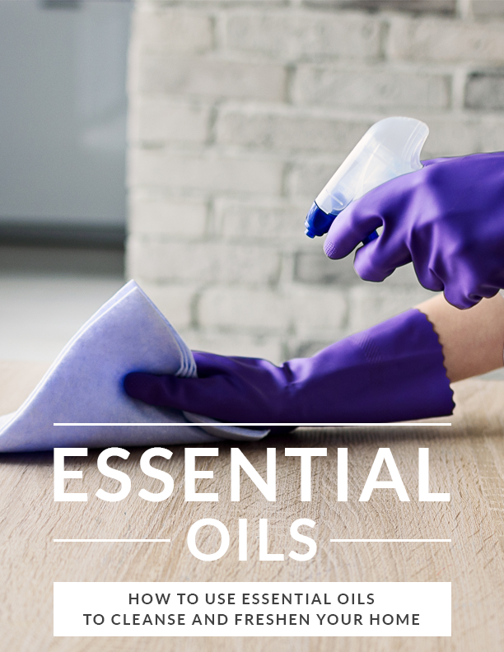
Contents
Introduction 4
Definition of Essential Oils 4
The Virtues of Baking Soda and Vinegar 5
Benefits of Herbal Oils 5
Move over chemicals…..herbal essential oils are here 6
Ways to use herbal oil natural cleansers 7
Sprays 7
Bottles 7
Let’s dig in deeper 8
Herbals oils in the kitchen 8
Disinfectants 8
Dishwashing liquid 8
Stain remover 9
Oven cleaner 9
Herbal oils used in the living room 9
Floor cleaner 9
Furniture polisher and cleaning 9
Air freshener 10
Herbal oils used in the bathroom 10
Mirror 10
The floors, the wall and the tub 10
The potty 10
Air freshener 11
The types of essence oils used in cleaning and their benefits. 11
Lemon essential oil 11
Tree tea essential oil 11
Rosemary essential oil 11
Orange essential oil 12
LAVENDER ESSENtial Oil 12
Eucalyptus EssentialOil 12
WHITE FIR ESSENTIAL oil 12
Thyme essential oil 12
Difference between chemical cleaning products and natural essence oil cleaning 12
Conclusion 13

Introduction

Your home is a place of relaxation, your sanctuary. Part of caring for your sanctuary is keeping it fresh and clean.
Unfortunately, you probably rely on expensive cleaning products that may be harming your health and the environment.
Most commercial cleaning products contain toxins that, when inhaled, can cause damage to your respiratory system and have additional adverse health effects on your children. Residue from these products can remain on surfaces long after you have wiped them off.
There is a safer way to clean your house with natural products made from essential oils that are both effective and safe.
Essential oils-based products are a safer, more cost-effective alternative because they are all natural and use basic ingredients that you probably already have in your kitchen. Essential oils are also highly effective in fighting germs and odor.

Definition of Essential Oils

Essential oils are extractions from various plants with distinctive aromas. They are usually extracted for use in soaps, perfumes and household products such as air fresheners or cleaners.
They can be used individually or combined with other natural products. The intent of essential oil use in household products is to lessen your exposure to harmful chemicals.
Lavender, peppermint, and tree oil are the most common essential oils for do-it-yourself household cleaners.

Adding Baking Soda and Vinegar

Baking Soda and vinegar must-haves in your kitchen and at every trip to the store. The combination of baking soda and vinegar can make your kitchen counter sparkle, remove stains from your carpet, and freshen your bathroom floors and walls. It is also cheaper and more effective than any product you can find in the market.
The addition of aromatic herbal oils makes it even better.

Benefits of Herbal Oils

Harsh chemicals in commercial cleaners can cause skin irritations, and leave an acrid scent. The natural ingredients in herbal oil cleaners pose no harm to your skin, and release a longer-lasting, more pleasant fragrance.
The residue droplets from a traditional spray air freshener or polisher can damage your furniture, but a errant drops from a natural spray cause no harm and make it smell that much better.
Cleaning materials can be bulky and space consuming. Natural cleaning products require only a spray bottle, and one cleaner can be used for various surfaces. It is a handy solution that saves money and shelf space.
Contrary to common conception, oil-based products require very little time or money to prepare. A product you can make at home will be cheaper than anything you find on the shelf, and a little essential oil can go a long way.

Move over chemicals…..herbal essential oils are here

Accepting the substitution of herbs for chemicals is not an easy switch if you are hypersensitive about germs or infections. But letting go of chemicals can actually be more of an improvement to your health than trying to eradicate all those pesky germs. You can start out small and simple by making your air spray herbal. Air fresheners can be made with components of citrus oil or lavender oil, both easily available and affordable. Dilute it with water and pour into a spray bottle for your first foray into chemical-free.
Next try cleaning surfaces. Pour more drops of herbal oil into diluted vinegar and baking soda, and clean as usual. Fewer bacteria; zero chemicals.
People have been embracing the benefits of herbal oils for thousands of years, and it was crucial that each herb was used either in its natural form or as a liquid or vapor to stave off bacteria and viruses. Incense oils have myriad cleansing and healing properties and promote a sense of relaxation; can the same be said for chemicals?

Ways to use herbal oil natural cleansers

There are two common methods for easily storing herbal oils. The original content bottle does not need to be taken out every day. Place a few drops into a product you will use frequently, and store the tiny bottle away.

Sprays

This method is convenient, easy to use, and keeps products out of direct contact with children. Open the bottle and fill it with either a combination of vinegar and baking soda or simply water, add a few drops of your desired oil, and fasten the sprayer cap tightly. In a matter of minutes you have made your own air freshener, polisher or cleaner.

Bottles

For areas that require more than a few sprays, like the bathrooms and kitchen, store your product in a bottle for more frequent use.
Although they are natural, always keep your products out of reach of children. Herbal oil works best when diluted. Too much of anything is good for nothing, so avoid using herbal oils directly; always mix them or dilute them.

Let’s dig in deeper

There are wide and varied opinions on the use and effectiveness of herbal oils. It is generally accepted that they have many external and internal benefits for the human body, but it is still unclear on just how effectively they ward off germs and bacteria.
However, nothing guarantees 100% percent reduction of germs, nor should we seek that. Regular care and cleaning—in any form—prevents bacterial and viral infections; herbal oils simply offer a completely safe and chemical-free option.

Herbals oils in the kitchen

The kitchen is in use every day, and needs to be cleaned at least as often. Dishes never seem to end, and food particles alone on the kitchen counter carry more bacteria than you can imagine.
The right mixture of herbal oils can help lighten your load.

Disinfectants

Although dinner smelled great when you were cooking it, the same is not true for all that leftover dirt and grime. Your kitchen needs a good scrub.

Your solution: soda, thyme essential oil, and warm water. Mix well in a spray bottle and apply as necessary to get your counters sparkling again.

Dishwashing liquid

Most dishwashing liquids include some component of citrus because of its appealing scent and power to remove particles. Unfortunately, those dishwashing liquids also contain chemicals you can do without. You can get all of the benefits and none of the harm by making your own natural mixture.
Lime and orange essential oils are most suitable for making this dishwashing liquid or soap. Combine these with your baking soda and vinegar.

Stain remover

Remove stubborn stains on the kitchen sink and rim edges without working too hard. Make a liquid or paste with a combination of rosemary, tree tea oil, and baking soda. Apply to the stains, let set for a few minutes, then scrub off.

Oven cleaner

Thyme and lemon grass oil are the best in grease elimination. Added to a little bit of baking soda, salt, and vinegar, they are a powerful natural scrubber.

Herbal oils used in the living room

Floor cleaner

A mixture of cyprus essential oil, lemon essential oil and warm water is great for polishing your floors. Mix in a bucket and apply with a mop or rag.

Furniture polisher and cleaning

A wood-safe option is a combination of orange essentials and white vinegar. Mix in a spray bottle for furniture use, or a bucket for floor application.

Air freshener

Refresh your air—and yourself—with a mix of lavender or rosemary oils.
Lavender promotes relaxing and soothing feelings that help calm your stress without the harmful chemicals.

Herbal oils used in the bathroom

The bathroom. It needs tidying and cleaning almost anytime of the day. The more people in the house, the harder it is to clean, and the more chemicals you use to keep it that way. Try a natural cleaning solution to make this chore easier, safer, and more efficient.

Mirror

Dip a microfiber cloth in citric oil diluted in water and wipe.

The floors, the wall and the tub

Oh, the disappointment when you put all the work into cleaning, and the walls and floors don’t shine. Shower cubicles and bathtubs need a lot of scrubbing. Citric oil and tea tree oil combined with a baking soda and vinegar solution is your answer. Apply to the surface and let it set, then scrub off.

The POTTY

Mix a solution of baking soda and enough vinegar to kill germs, and add either lavender or citric essence. Pour into the bowl and scrub for a germ-free, pleasant-smelling bathroom.

Air freshener

There are two methods to freshen your air. Dilute a few drops in a spray bottle of water and spray as desired, or keep a combination of the oil and water in a slightly open jar.

The types of essence oils used in cleaning and their benefits.

Different oil extractions have different benefits. Some have powerful individual benefits, and others are more effective when combined with other products or oils.

Lemon essential oil

A common oil preferred for its higher capability of preventing bacterial and viral infections.

Tree tea essential oil

Also effective for fighting germs and commonly used in bathroom and kitchen cleaning products.

Rosemary essential oil

Contains effective antiseptic qualities that makes it useful in cleaning products.

WILD Orange essential oil

Excellent for cutting through grease on countertops.

LAVENDER ESSENCE Oil

Naturally fragrant with multiple anti-bacterial components.

Eucalyptus Essence Oil

Efficient at removing stains and grime while also fighting germs.

White fir essence oil

Also commonly used in many cleaning products, it is widely available and effective.

Thyme essence oil

Of all the essential oils, thyme is most powerful in germ fighting. Consider it a necessity!

Difference between chemical cleaning products and natural essence oil cleaning

The strong, sometimes overwhelming, smell of disinfectant that accompanies chemical cleaners does not lend your home a comfortable feeling. Simple solutions of baking soda, vinegar, and various oils provide a much safe and more appealing alternative.
Many branded cleaning products are expensive, and cheaper chemical products tend to be less effective. Cleaning products compete in quality verses quantity. With essential oils, you get both. The quality is high, but the cost is extremely reasonable for its concentration and longevity.
Essential oils can be combined with each other for added benefits, and no harmful side effects.
For purchasing information or to schedule a strategy session, please contact me at sharon@sharonotness.com

Conclusion

Essentiall oils have been used in households for their therapeutic effects for thousands of years. With advanced technology, these oils are more available and more versatile than ever before.
It is important to maintain the sacred values and properties of essential oils. It is preferred to use them only with diluted water, but they may also be combined with baking soda and vinegar.
The purest, most organic form is the best way to use an essential oil. When you are purchasing them, make sure to select products that are not mixed with any other components.
Natural essential oils and products promote a healthier, quicker cleaning routine.
Herbal essential oils are made from natural components that have no side effects if inhaled or in contact with the skin. Society is becoming more aware of harmful effects of chemicals, and more traditional, natural products are more mainstream.
These easy methods of creating your own natural cleaning products are a cost-effective and progressive step in the right direction.
Make use of what nature has given us.

I use certified pure therapeutic grade essential oils from doTerra.
If you would like to purchase any of these oils you many get them here. For any questions please reach out and I am happy to schedule an appointment with you to make sure you get what you need. sharon@sharonotnnes.com

To your health,
Sharon

